**Stock Analysis and Prediction**

C.Aditya Shashank, Dr.C.R.K.Reddy

Dept. of Computer Science and Engineering

MAHATMA GANDHI INSTITUTE OF TECHNOLOGY

GANDIPET, HYDERABAD, INDIA

chinta.aditya.vishakha@gmail.com

***Abstract****:* **Prediction has Always been the human criteria. In this paper we are going to predict the things in every aspect and at every aspect. Analysis of stocks using data mining will be useful for new investors to invest  in the stock market based on the various factors considered by the software .Our  code will be analyzing Sensex based on company’s stock value data . The stock values of company depend on many factors, some of them are: Demand and Supply: Demand and Supply of shares of a company is a major reason price change in stocks. When Demand Increase and Supply is less, price rises. and vice versa. Corporate results*:*  This will be regarding to the profits or progress of the company over a span of time say 3 months. Popularity*:* Main Strength in hands of share buyer. Popularity of a company can influence buyers. For instance any good news associated with company, may result in the rise of stock prices and bad news may break dreams.**

**The proposed paper examines the use of the prediction system in real-world and issues associated with the accuracy of the overall values given and predicted. The paper also presents a machine-learning model to predict the longevity of stock in a competitive market. The successful prediction of the stock will be a great asset for the stock market institutions and will provide real-life solutions to the problems that stock investors face.**

***Keywords—LSTM (Long Short-Term Memory), Machine Learning, Predictions, Moving Average.***

1. INTRODUCTION

Analysis of stocks using data mining will be useful for new investors to invest in stock market based on the various factors considered by the software. Our software will be analyzing Sensex based on company’s stock value. Lately, many researchers are using more of ensemble learning techniques. It would use low price and time lags to predict future highs while another network would use lagged highs to predict future highs. These predictions were used to from stock prices.

Existing System: The existing system fails when there are rare outcomes or predictors, as the algorithm is based on bootstrap sampling. The previous results indicate that the stock price is unpredictable when the traditional classifier is used. The existence system reported highly predictive values, by selecting an appropriate time period for their experiment to obtain highly predictive scores. It doesn’t focus on external events in the environment, like news events or social media. It exploits only one data source, thus highly biased.

Proposed System: In this proposed system, we focus on predicting the stock values using machine learning algorithms like Moving Average, LSTM. We proposed the system “Stock market price prediction” we have predicted the stock market price using the LSTM**.** We used all these features to train the machine on LSTM model and predicted the object variable, which is the price for a given day. The proposed system touches different areas of research including data pre-processing, recurrent neural networks and so on.

Minimum required specifications: Pentium Dual core, Hard Disk-256GB, RAM- 512 MB, Cache-512KB.

1. RELATED WORK

S. AbdulsalamSulaimanOlaniyi, Adewale’s. Kayode, R. G. Jammeh:  Stock Trend Prediction Using Regression Analysis customers. The combination of Min-Max normalization and K-Nearest Neighbor (K-NN) classifier are used and implemented in R. This proposed model provides the important information with the highest accuracy. It is used to predict the loan status in commercial banks using machine learning classifier [1]

Shyi-Ming , Chengyu-Chua : Multivariable Fuzzy Forecasting Based on Fuzzy Clustering and Fuzzy Rule Interpolation Techniques. This model provides a performance evaluation of credit card default prediction. Thus, logistic regression, rpart decision tree, and random forest are used to test the variable in predicting credit default and random forest proved to have the higher accuracy and area under the curve.

[Top Bahadur Pun ,Tej Bahadur Shahi :](https://ieeexplore.ieee.org/author/37086471744) Stock Exchange price prediction is the task of estimating future price of certain stock listed in the stock exchange by extracting the trend with the help of confidence learned from historical training data. Support Vector Regression (SVR) and Artificial Neural Network (ANN) are applied in order to predict stock price for a next day. In order to measure the performance of two learning models, mean square error (MSE), mean absolute error (MAE), root mean square error (RMSE) and Coefficient of Determination (R 2 ) /

# DESIGN AND METHODOLOGY

Framework: The architecture of the proposed model consists of three phases mainly. pre-processing phase. Data Visualization (testing and training phase) 3. Result.

The Architecture of the Proposed Model.

**(Train Model)**

Moving Average,Long Short Term Memory(LSTM)

Data base

Figure 1: Architecture of The Model

Plot predicted Results

Predict stocks for n days using RNN

Refined Data

Dataset: The Dataset is taken form “Yahoo finance!”. This dataset can be used in the study of Stock analysis by pre-processing the data and training the data.

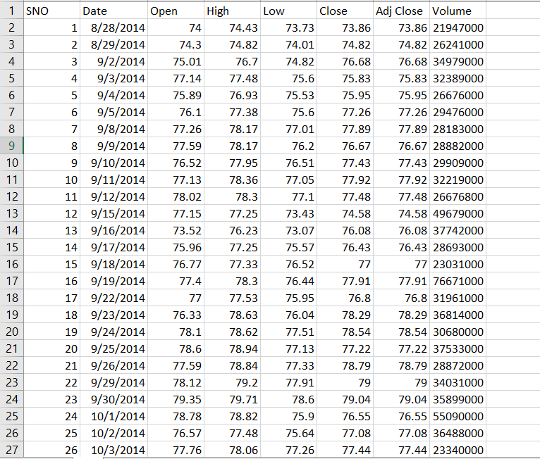

Figure 2: Dataset refined from Yahoo Finance

There are multiple variables in the dataset – date, open, high, low, last, close, AdjClose, Volume.

The columns Open and *Close* represent the starting and final price at which the stock is traded on a particular day.

High, Low and Last represent the maximum, minimum, and last price of the share for the day. AdjClose is the average of the total closes on hourly basis of shares bought or sold in the day and Volume is the number of variations a company has been witnessing on any given date.

Another important thing to note is that the market is closed on weekends and public holidays. Notice the above table again, some date values are missing – 2/10/2018, 6/10/2018, 7/10/2018. Of these dates, 2nd is a national holiday while 6th and 7th fall on a weekend.

The profit or loss calculation is usually determined by the closing price of a stock for the day; hence we will consider the closing price as the target variable. Let’s plot the target variable to understand how it’s shaping up in our data.

Training: During training, the model is given labelled data from a training data set. In this project, the labelled training data are a large set of Stock values consisting of opening and closing prices on day to day basis. During the training process, two approaches have been chosen Moving Average and Long Short-Term Memory (LSTM).

Testing (Evaluating): During testing, the machine learning system is given. In our case, these data are refined as such without any redundancy. Depending on the Training set, the classifier predicts the closing prices of the stocks on day to day basis. This classification is compared to the true value of closing prices and parasitized to measure performance.

1. RESULTS

 We will evaluate the model we built in the training phase by making predictions with them on the data from our test dataset because just validation is not enough. We have also built a module called LSTM model, which we can use to evaluate the performance of our deep learning models with relevant classification metrics. The first step is to scale our test data.

The next step involves loading our saved deep learning model and making predictions on the test data.

The final step is to leverage our model evaluation using matplotlib. pyplot module and check the performance of model with relevant classification metrics.

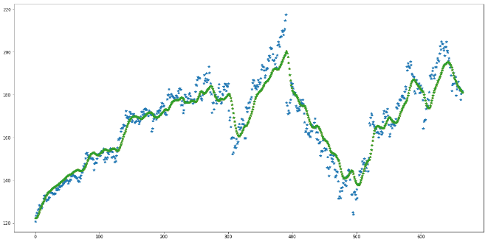

Figure 3. Output of testing and Classification Report

V.CONCLUSION

This project proposes a machine learning algorithm that integrates Deep learning model and Recurrent Neural Networks **for** Stock Price Prediction using financial technical indicators These indicators include relative strength index, money flow index, exponential moving average. The Proposed LSTM model builds a model which helps in predicting the closing stock prices of the company using time variant analysis. It predicts with better accuracy. also, it is capable to overcome the problems of various indicators. The performance of the proposed model is better than many algorithms which are currently in existence.

Our model can be extended by increasing the no of layers and considering more factors for evaluation of the stocks and implementing more deep learning model. The model can be extended using a bigger dataset and creating a better UI for the model.

REFERENCES

[1]. Ashish Sharma, Dinesh Bhuriya, Upendra Singh. "Survey of Stock Market Prediction Using Machine Learning Approach", ICECA 2017.

[2].https://www.cs.princeton.edu/sites/default/files/uploads/Saahil_magde. pdf

[3]Hako GRIGORYAN, “A Stock Market Prediction Method Based on Support Vector Machines (SVM) and Independent Component Analysis (ICA)”, DSJ 2016.

[4]Loke.K.S. “Impact Of Financial Ratios And Technical Analysis On Stock Price Prediction Using Random Forests”, IEEE, 2017.

[5]Prediction”, IJPAM 2017. 10. Pei-Yuan Zhou , Keith C.C. Chan, Member, IEEE, and Carol XiaojuanOu, “Corporate Communication Network .

[6]RautSushrut Deepak, ShindeIshaUday, Dr. D. Malathi, “Machine Learning Approach In Stock Market

[7] SachinSampatPatil, Prof. Kailash Patidar, Asst. Prof. Megha Jain, “A Survey on Stock Market Prediction Using SVM”, IJCTET 2016.

[8].VivekKanade,BhausahebDevikar, SayaliPhadatare,PranaliMunde, ShubhangiSonone.“Stock Market Prediction: Using Historical Data Analysis”, IJARCSSE 2017.

[9]Xi Zhang1, Siyu Qu1, Jieyun Huang1, Binxing Fang1, Philip Yu2, “Stock Market Prediction via Multi-Source Multiple Instance Learning.” IEEE 2018.